**University of Sussex 2019**

**School of Engineering and Informatics**

Computer Science Project Report

Compiler for a language with Erlang-like multithreading

**Candidate No:**

164835

**Supervisor:**

Dr. Martin Berger

**Statement of originality**

This report is submitted as part requirement for the degree of BSc Computer Science at the University of Sussex. It is the product of

my own labour except where indicated in the text. The report may be freely copied and distributed provided the source is acknowledged.

**Date**: _____________ **Signature**: _____________

**Summary**

The following report describes the details of an attempt to create a compiler with an integrated concurrency (or multithreading) model based on the one found in the Erlang programming language. The intended target architecture for the compiler is LLVM and its language LLVM IR (Intermediate Representation). The source language that is to be compiled is essentially a modified version of Kaleidoscope programming language with some extended functionality.

The report will explore the key concepts involved in the project, break down intended and achieved functionality of the target language, details of design and how it was affected by the implementation process and the said concepts.

The report will be finalized with evaluation and reflection of the the work that has been done, breakdown of the reasons behind incomplete aspects of the final (at the time of submission) system, aspects to be completed and future improvements.

Table of Contents

Introduction 2

Ethical and professional considerations 5

 Addressing ethical issues 5

 Addressing BCS Code of Conduct 5

Requirements analysis and specification 6

System design and development 8

 The source language 8

 Target language and architecture 9

 Implementation language (Haskell) 10

 Concurrency and Erlang 11

 The compiler 12

 Lexer (lexical analysis) 13

 Parser (syntactical analysis) 14

 Semantic analysis 16

 Code generation 16

 Additional notes on development 18

Implementation and testing 19

 Lexer (Lexer.hs) 20

 Parser (Parser.hs) 21

 Code generator (Codegen.hs) 23

 Compiling (Compiler.hs) 24

 Concurrency 25

 Notes on testing 25

System evaluation 26

Reflection and conclusion 27

References 29

Appendices 31

 Project log (initial) 31

 Project log (final) 31

 Erleidoscope specification (CFG) 32

 Erleidoscope specification (Haskell) 32

 Code and output examples 33

# Introduction

All central processing units (CPUs), no matter how advanced, at their core are complicated machines but those that can only understand (collections of) simple commands. These commands are not produced with something like a general purpose programming language but they are rather binary sequences (sequences of 1s and 0s) referred to as machine code, that make a processor behave in one way or another. It is impossible for one to actually program in machine code, which is why all major manufacturers have a set of basic commands, that are more human-readable, ‘baked’ on to their processors. The translation of these commands to machine code takes place ‘under the hood’ and is generally out of user’s control. These commands make up what is called assembly language and are used to manipulate registers and the data contained in them, as well as jump within the assembly code itself between the lines of code. Registers are local storage spaces that hold data to be processed by the CPU. The exact syntax of assembly languages, often referred to as low-level, depends on the manufacturer and processor architecture (e.g. x86, ARM, MIPS, GPU), but each provides the same essential functionality and manipulations.

Programming directly in assembly language is not a common practice nowadays and developers or software engineers are more likely to exploit one or more of the many existing, so called, high-level programming languages (like Java, C/C++, Python, JavaScript, etc.), that are more understandable and far more efficient to use because of the functionality they provide: e.g. various data structures like lists, maps, stacks and easy manipulation of these structures; control-flow structures like loops and conditional statements, which aren’t as straightforward to use in low-level languages; efficiently split code into functions or methods (although, LLVM does have its own implementation of functions). But as was mentioned before, on the lowest level processors operate in machine code and the lowest-level human-readable language is assembly. Therefore, a mechanism is required that will perform the ‘translation’ of a program written in high-level language to assembly (low-level language). This mechanism is a compiler.

The internal workings of a compiler are usually hidden from the user and should not be a concern when one develops programs using high-level languages. However, understanding of these ‘under-the-hood’ processes and the ability of replicate them can be a valuable addition to a skill set of a programmer, especially for the purpose of, for instance, developing one’s own programming language. In addition, developing a compiler can be beneficial in several other ways:

* it gives a better understanding of low-level languages which are important in creating complex systems (e.g. operating systems);
* it gives an insight into the processes that take place in the background when compiling and running code written in higher-level languages.

The above makes part of the motivation behind this project in addition to exploring the concept of concurrency and how it can be implemented from scratch. The idea of concurrency, which for the purpose of this project will sometimes be referred to as multithreading, will be discussed in more detail further in the report, but for for now, it can generally be defined as the ability of a system to execute multiple processes simultaneously, or at least, give an impression of processes running in parallel **[2]**. The latter is especially relevant for single-core processors, as it is physically impossible for them to run several processes in parallel, but through inter-process communication and scheduling algorithms, both of which happen at a rate that is impossible for user to comprehend, various tasks (processes) can have an appearance of running simultaneously.

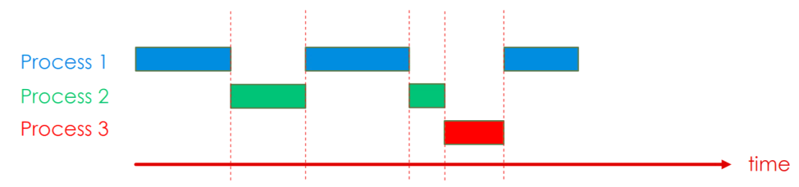

**Image 1.** Processes executed concurrently over time **[2]**.

However, with multicore processors growing in popularity, the workload is taken off a single core and processes are distributed across multiple cores which decreases the time it takes to complete a task, thus, improving efficiency and, potentially, the life time of CPU. Some programming languages even have support for concurrent programming, meaning that multiple threads of execution can be initiated manually by a programmer.

Thus, the the main objectives of this project are: develop a compiler for a toy programming language, the syntax of which will be described in the following sections of this report (as well as in the appendix); modify the language and try to replicate the concurrency model of Erlang programming language (i.e. its scheduler and possibly message passing between processes).

In the following chapters, the report will first discuss ethical considerations like involvement of human subjects or ethical questions, and professional considerations with addressing some sections of the BCS Code of Conduct, followed by the main body containing the breakdown of the requirements for the end product of the project. Then it will discuss the details of system design, implementation of the compiler, significance and limitations of tools used in development, challenges faced along the line and finalize with conclusion, reflecting on the work and underline potential improvements, fixes and further developments.

# Ethical and professional considerations

##  Addressing ethical issues

This project is based on research of compilers and their internal workings, certain functionality of programming languages and practical implementation of said features and is intended for personal use. No target users are considered at any point in the project for development or testing purposes. The project does not require research that involves human subjects or participants and does not raise any legal, social or political issues. Therefore, as the project does not involve any ethical considerations, it does not require ethical review or compliance forms.

##  Addressing BCS Code of Conduct

The sections of BCS Code of Conduct discussed below are considered to be more relevant and worth mentioning in relation to this project specifically, whilst others have been disregarded.

(Public Interest)

This project does not directly concern any points in the Public Interest section of the BCS Code of Conduct by being mostly technical throughout and not involving any social, ethical, environmental or any other issues mentioned in points 1, 2 and 3. To honor point 4 the work that has been carried out in the project (source code and other materials) is made public and free to explore on GitHub.

(Professional Competence and Integrity)

The project is not meant to provide any professional services, but is meant to help develop certain skills and understanding of its ideas and subjects, add to the existing knowledge and fill in the possible gaps. The results produced as the result are within level of competence of the author and any feedback and honest criticism is greatly appreciated.

# Requirements analysis and specification

This section goes over system requirements for the compiler, specifying such details as implementation language, source language for the compiler, target architecture (language), language of implementation, overall functionality that should be achieved.

 Functional requirements:

- the compiler, or the file or function that makes the compiler should take a string as an input, which is a program written in the source language and produce a file containing the equivalent of the input program as output, but presented with target low-level language;

- the source program should be able to be applied as a string directly to the compiling function or derived from a file;

- the output file can only be produced if of all stages of the compiler have processed the input without errors, it may not, however, guarantee successful execution of the output program;

- should an error occur at any stage of compilation the system should say so on the screen (in the terminal) with at least an indication of the compilation step where the said error took place, and ideally, whenever possible include details as to which part of the source program is faulty (e.g. parameters declaration, wrong data type used in an operation, possibly missing brackets, etc.);

- a successfully produced program in target language compiled from an ideally written source program should be successfully run using the the target architecture simulator;

- errors that arise when running the output program using the architecture simulator shall also be displayed but shall not be caught or altered in any way.

 Non-functional requirements:

- for optimal compatibility and efficient manipulation and execution of files in the project all the development is performed in Linux operating system (Ubuntu, to be specific);

- the code in the files representing compiler steps are written using VIM editor, rather than any known IDE;

- the implementation language, i.e. the language that the compiler is written in is Haskell (.hs file extension), a functional, statically typed programming language with built-in type inference and lazy evaluation **[3]**;

- Haskell code is compiled by Glasgow Haskell Compiler (GHCi in the terminal);

- the files with extension .ll (low-level code) produced as the result of compilation of the source language are run using LLI – a LLVM interpreter and dynamic compiler.

# System design and development

This section goes over a detailed description of the compiler design, including a formal description of the source language, explanation of stages of compilation, the target architecture, reasoning behind certain unconventional practices that were used in development of the compiler.

##  The source language

The source language for the compiler was not developed entirely from scratch. A version of this language was featured in the previous years of study, more specifically in the Compilers and Computer Architecture module as a source language for the coursework.The core specification of the language was borrowed from the assignment brief and then modified to include some essential missing features that are present in most programming languages. These features include such data types as Strings and Booleans, as well as the ability to output some of the available expressions with a printing function. The source language also closely resembles Kaleidoscope, a toy programming language featured as an example source language in a tutorial for language implementation with LLVM **[4].** It should be noted that some parts of the language were added (and some were considered to be added) at later stages in development due to some difficulties in implementation, specifically for the chosen target architecture, which is LLVM. Such parts include, for instance, declaration of data types for function’s parameters in the function signature.

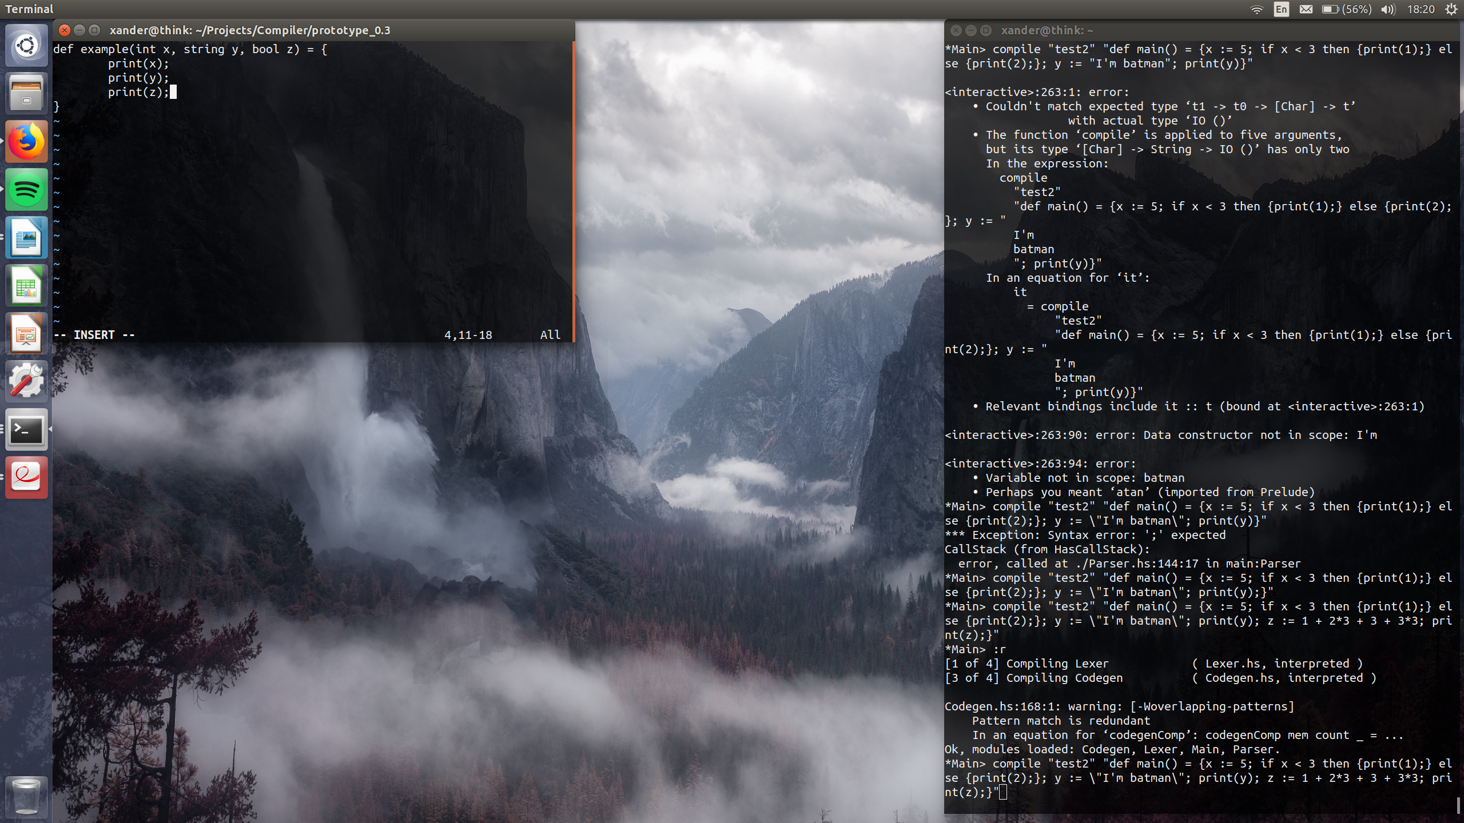

**Code snippet 1.** Declaring parameter’s types.

In addition, the intended ability to initiate multiple threads of execution (at least for scheduling), while was added to the language syntax and can be processed by compiler’s front end (i.e. lexical and syntactical analysis), was not fully implemented and is not processed in the back end, which is the final stage of compilation (more on that later in the report). Some other limitations in the usability of the language are also present and will be explained. Because of language’s resemblance to Kaleidoscope and the concurrency model is based on that of Erlang, the source programming language for the compiler shall further be referred to as Erleidoscope. The full specification for Erleidoscope with a context-free grammar is available in the appendix, with example programs.

##  Target language and architecture

There were several architectures that were considered as target for the compiler. Some of them, like Intel’s x86, were ruled out due to the existence of different complex revisions or simply because they are considered a complicated target to compile to, partially due to amount of features it comes with. Other considered architectures were ARM and MIPS, especially MIPS due to existing knowledge and past practice with this architecture.

The final choice for target architecture, LLVM (Low Level Virtual Machine) **[5]**, was made quite late in the development of the compiler what resulted in certain changes in the syntax of Erleidoscope and may seem a little ‘out-of-place’. LLVM is an infrastructure project, a collection of tools for development of compiler front ends and back ends **[5]**. There are several reasons, apart from strong recommendation from the supervisor, behind choosing LLVM as target architecture: it essentially serves as an middle layer of a complete system, i.e. that the code produced for LLVM is basically independent from the system it is executed on and therefore is automatically optimized and converted to be supported by pretty much any machine it is run on, whether it is x86, ARM, etc; the language of LLVM, LLVM IR, which stands for Intermediate Representation, is structured similarly to some of the high-level general purpose languages like Java or C++, in that, the code is clearly split into functions or methods (see the code snippet below), has relatively straightforward support of strings, even though they must be declared as global variables, as well as a separate function for printing, which must also be declared in the code to be successfully called.

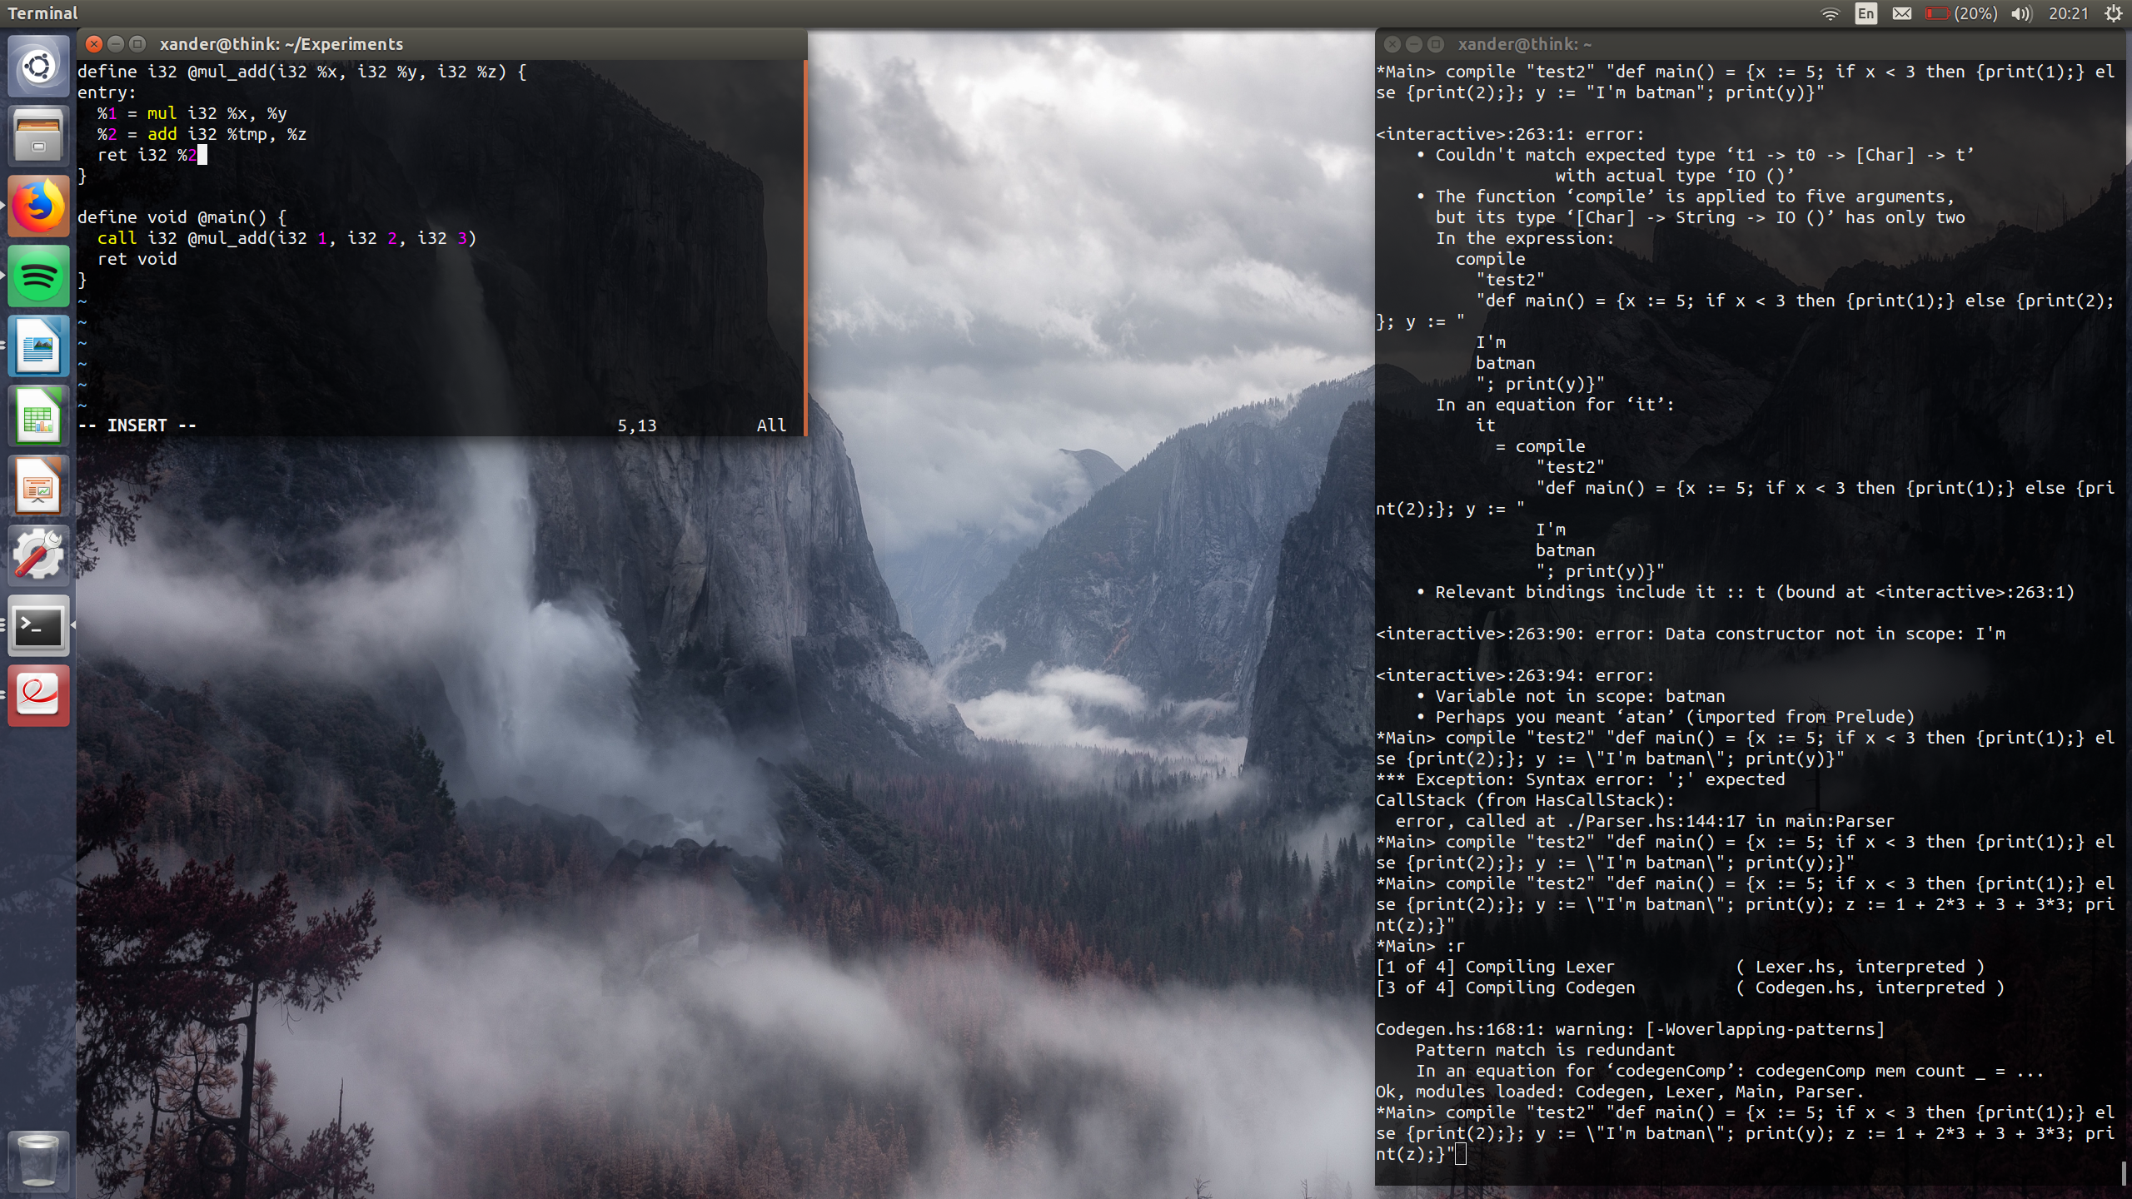

**Code snippet 2.** Example of LLVM IR program.

##  Implementation language (Haskell)

Haskell is a popular choice for compiler writing in the online developers community **[6].** Descriptions of languages with a context-free grammar are generally recursive in nature (see the image below) and Haskell provides an efficient way of defining recursive data types and functions, which is also useful when working with trees, which are an important structure in compiler development.

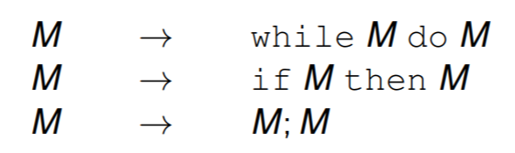

**Image 2.** Example CFG.

Other important features include but aren’t limited to pattern matching, list comprehension, different ways of representing conditional statements and more. Moreover, Haskell provides dedicated tool kits targeted specifically at developing compiler systems. There are tutorials and papers that go over the process of creating a compiler in Haskell with the use of these tool kits, including one by Stephen Diehl, for Kaleidoscope programming language **[4]**. However, these sources while could be proven useful, will not be referred to and the tool kits were not used in creation of the compiler for Erleidoscope but rather it was created from scratch mostly for educational purposes.

##  Concurrency and Erlang

Concurrency was already briefly mentioned early in the report. In an operating system, processes that are running concurrently create an illusion of being executed in parallel, while in reality each process is executed for a certain amount of time before letting the next process in the queue to take over CPU’s resources and execute again for some amount of time before it is put in the end of the queue. The time that a process has to execute is normally decided by a scheduling algorithm that with the use of some information from the processes, the CPU, statistical data about execution times and some mathematical function determines the time that some task (process) can be processed for by the CPU. That is a typical description of how concurrency is handled in an operating system and as was mentioned before, some programming languages support concurrent programming, i.e. manually spawn separate threads (processes) for performing different tasks. However, the way Erlang handles concurrency is pretty unique and unconventional compared to how concurrent processes are normally treated.

First of all, Erlang, like Haskell, is a functional, concurrent, general purpose programming language used to build scalable real-time systems **[7]**. The unique concurrency model of Erlang is the inspiration for concurrency in Erleidoscope, more specifically, the aspect of interest is the scheduler and potentially the message passing system. Every operation in an Erlang program, (a function call, an arithmetical operation) is assigned a special value that essentially operates like a counter, but it does not count down time like most scheduling algorithms. This value represents the number of reduction steps and is reduced with each step of the operation that is being performed. The virtual machine then uses these reduction steps to measure the process’ level of activity. When a new process is created (spawned), a number of reductions is assigned to it and this number is decreased for every executed operation. As soon as the reduction steps value of a process counts to zero, it is preempted, i.e. interrupted in its execution and is placed at the end of the processes queue. Such methodology guarantees not necessarily equal, but fair allocation of time and resources for execution among the processes **[8]**. A similar scheduling strategy was intended for implementation in the Erleidoscope language.

##  The compiler

In simple terms, the job of a compiler is to ‘translate’ high-level code into low-level assembly code, but this transition does not happen in a single step. A standard compiler pipeline involves several processing stages. Each stage essentially simplifies the job of the following stage by transforming the initial high-level input in a certain way. These three main stages and the ones that are implemented for compiling Erleidoscope are lexical analysis (lexing), syntactical analysis (parsing), and code generation.

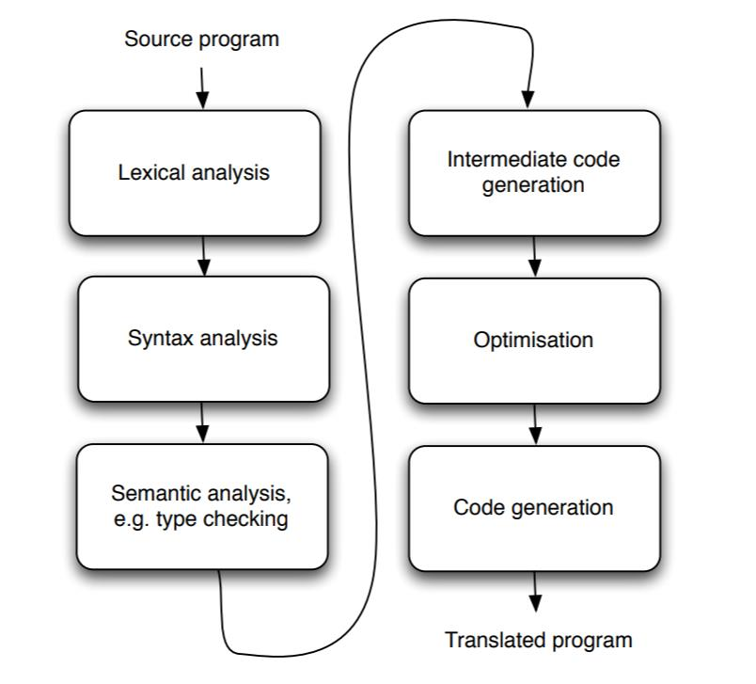

**Image 3.** Full stack of compilation stages **[1]**.

##  Lexer (lexical analysis)

Lexical analysis is the first phase of compilation. In this phase, the input, a long string written in Erleidoscope is processed by what is called lexer **[9]**. In the context of this project, lexer performs a series of splits on the input string, producing a list of strings and/or characters that represent future tokens or parts of tokens. This list is then processed to build the string representations of the valid elements of the language specified by its CFG. It also eliminates redundant information such as empty spaces, new lines, tabs that are not important for further processing **[9]**. Finally, the list of strings is used to build the list of tokens, the actual valid components of the source language, at least not in Kaleidoscope.

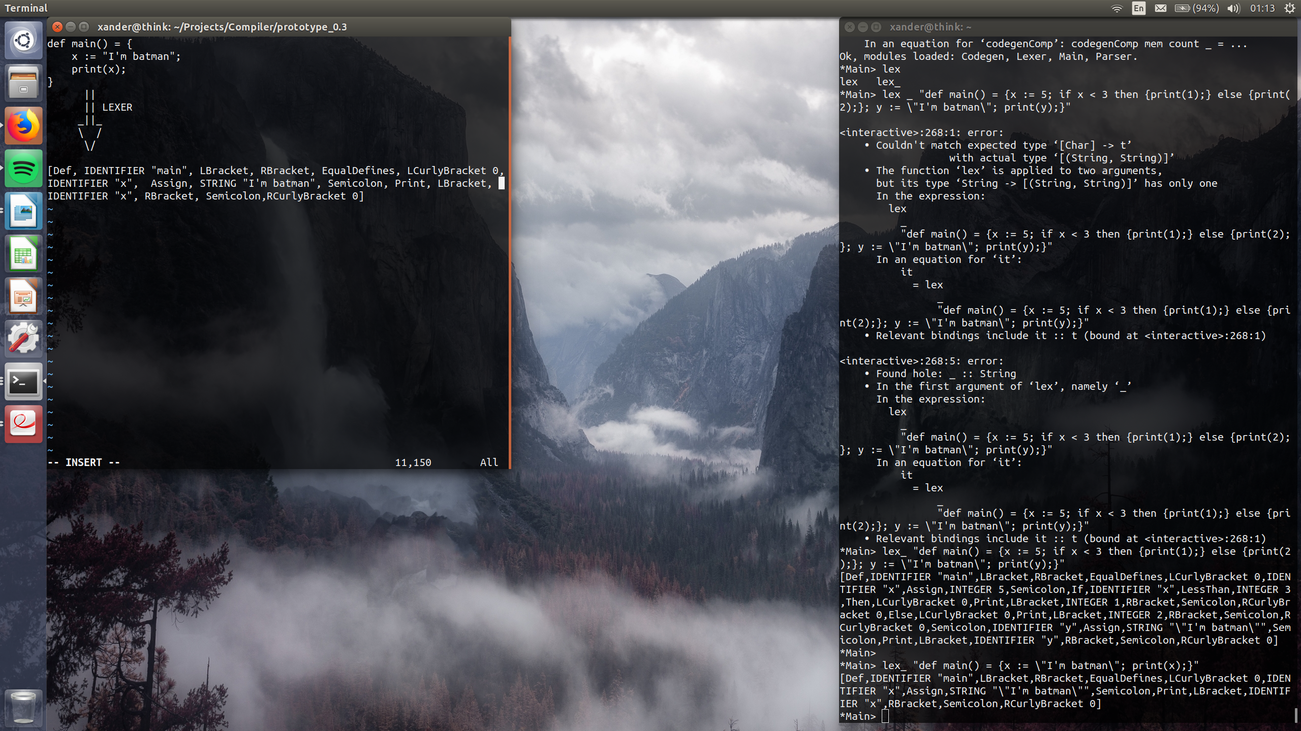

**Code snippet 3.** Erleidoscope program processed by lexer.

Lexing, however does not guarantee that the input string makes any programmatic sense, even if it produces a list of all valid tokens. It is simply meant to transform the input into a more convenient structure for processing by the next stage of compilation which is syntactical analysis or parsing.

##  Parser (syntactical analysis)

Parser receives the aforementioned collection of tokens produced by the lexer for processing. The is to check the coherence of the inputs, hence detect inputs with incorrect syntax and produce abstract syntax trees (ASTs) for those that are correct. AST, as the name implies, is a tree representation of syntactic structure of the source code **[10]**.

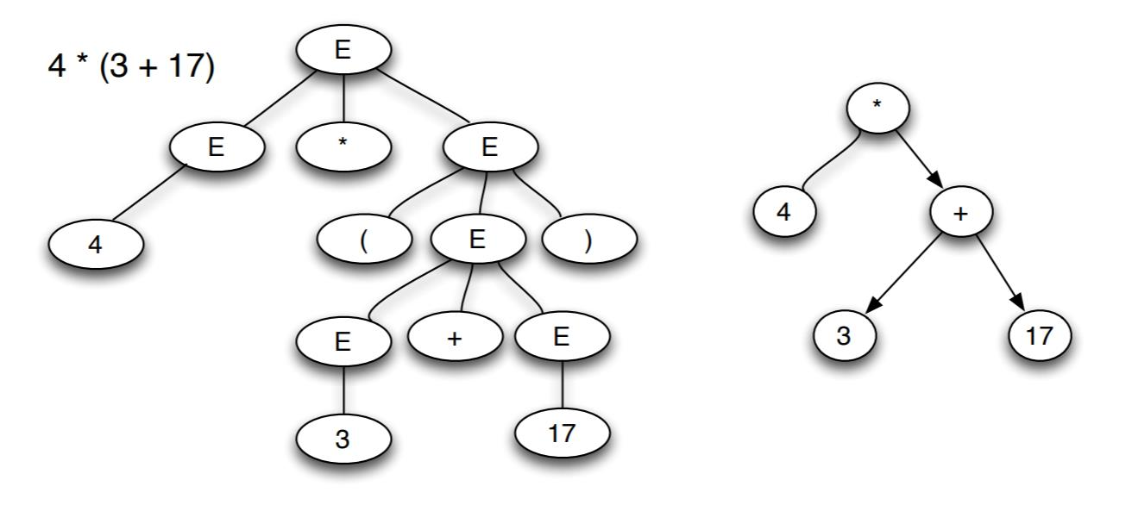

**Image 4.** Example of an AST for an arithmetic operation.

In a bit of an unusual move, before actually processing the token list to produce the AST, the token list is reformed by a series of functions to list containing nested lists of tokens. That way it is easier to distinguish between whole functions, blocks of code and individual expressions. Thus, the token list is analyzed several times for slightly different purposes, which potentially harms speed and efficiency of compilation, but since performance is not the focus for this revision of the compiler this point will not be emphasized. The reformed list is then goes through the main parser and its functions to produce the actual AST. Parsing, like lexing, also clears out information that is no longer useful for compilation. Such information includes brackets, that were used for detecting blocks of code or enclosed parameters or arguments of functions, or semicolons that indicate separation between expressions. It should be pointed out, that the resulting AST does not entirely consists of individual nodes. In places were it is more convenient for processing like sequences of functions, arguments, parameters or expressions sequences, some nodes are represented as lists, which allows to avoid overloading the tree with nodes when the input program is long and complex (e.g. a long arithmetic expression). For Erleidoscope, the AST is pushed straight to code generation phase, but it is common in compilation practice to also perform semantic analysis prior to trying to generate the low-level code.

##  Semantic analysis

Semantic analysis serves as the ‘last line of defense’ before proceeding to code generation, as its task is to catch errors that were not spotted in previous stages (e.g. using variable before it was declared, type-checking, etc.) **[11]**. For possible future revision of the Erleidoscope compiler, a form of semantic analysis like type inferencing could potentially be implemented for the purpose of extending the scope of the project and simplify specification of Erleidoscope, i.e. exclude parameter type declaration. Type inference is a mechanism that works out the types of variables, parameters or arguments based on their use in the body of a function. Once it’s been confirmed that the input string is free of lexical and syntax errors and (optionally) had semantic analysis performed on it, the AST derived from it is used as input for code generation phase.

##  Code generation

As was shown on the compiler pipeline earlier, before final code generation there are two additional phases: intermediate code generation and optimization. For the sake of reducing implementation time, these steps were disregarded and also will not be mentioned in the following chapters. However, as LLVM performs optimization of LLVM IR ‘behind the scenes’ before generating compatible code for an actual CPU architecture, code generation phase implemented for Erleidoscope compiler can be considered as that intermediate generation part, with optimization and final code generation taking place automatically ‘under the hood’.

Generation phase converts the intermediate representation of the input string (e.g. AST produced by the parser) into its low-level representation in assembly language **[12]**. In the case of this project, the code generator produces an output in LLVM IR language. The low-level output will then be processed to be executed by the LLI interpreter, which can optimize the input to be executed on any supported architecture.

Again, some aspects of the target architecture resulted in some uncommon implementation choices. As was mentioned before, in LLVM IR all strings used in the code have to be declared as global variables in the beginning of the code. The solution for this problem, once more maybe not very efficient but functional, is to analyze the input AST for the presence of stings and produce LLVM IR code accordingly.

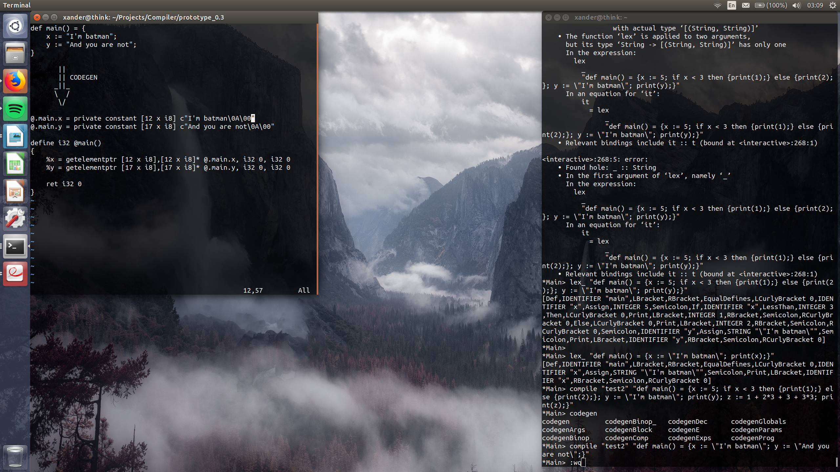

**Code snippet 4.** Example of compiling Erleidoscope code with strings

Additionally (not shown above), when compiling any Erleidoscope program some extra LLVM IR code is added to the output by default. This code includes a printing function, a function for printing booleans based on a single bit value 0 (for false) or 1 (for true), and some global variables for printing booleans and integers.

##  Additional notes on development

The development and design of the system was largely dictated by the implementation process, certain aspects of Haskell and LLVM, time constraints and issues that arose when creating the compiler, all of which will be addressed in the following sections of the report.

To establish some form of version control for the compiler and prevent loss of code (which took place anyway), a GitHub repository was created and linked to the project directory on the machine. The repository has been being updated with semi-regular commits on varying basis (from monthly to hourly). Also, constructors for left and right curly brackets have additional integer parameters with them, that will help detect complete blocks during parsing.

# Implementation and testing

This section describes the details of implementation of the Erleidoscope programming language and the compiler for it, mentioning certain challenges that were encountered and how or if they were resolved, the policy of transition to another revision (version) of compiler and how certain features were intended to be implemented. Testing methods and complications are also discussed.

First of all, the revisions of the compiler should be explained and why only one can be counted as complete and usable.

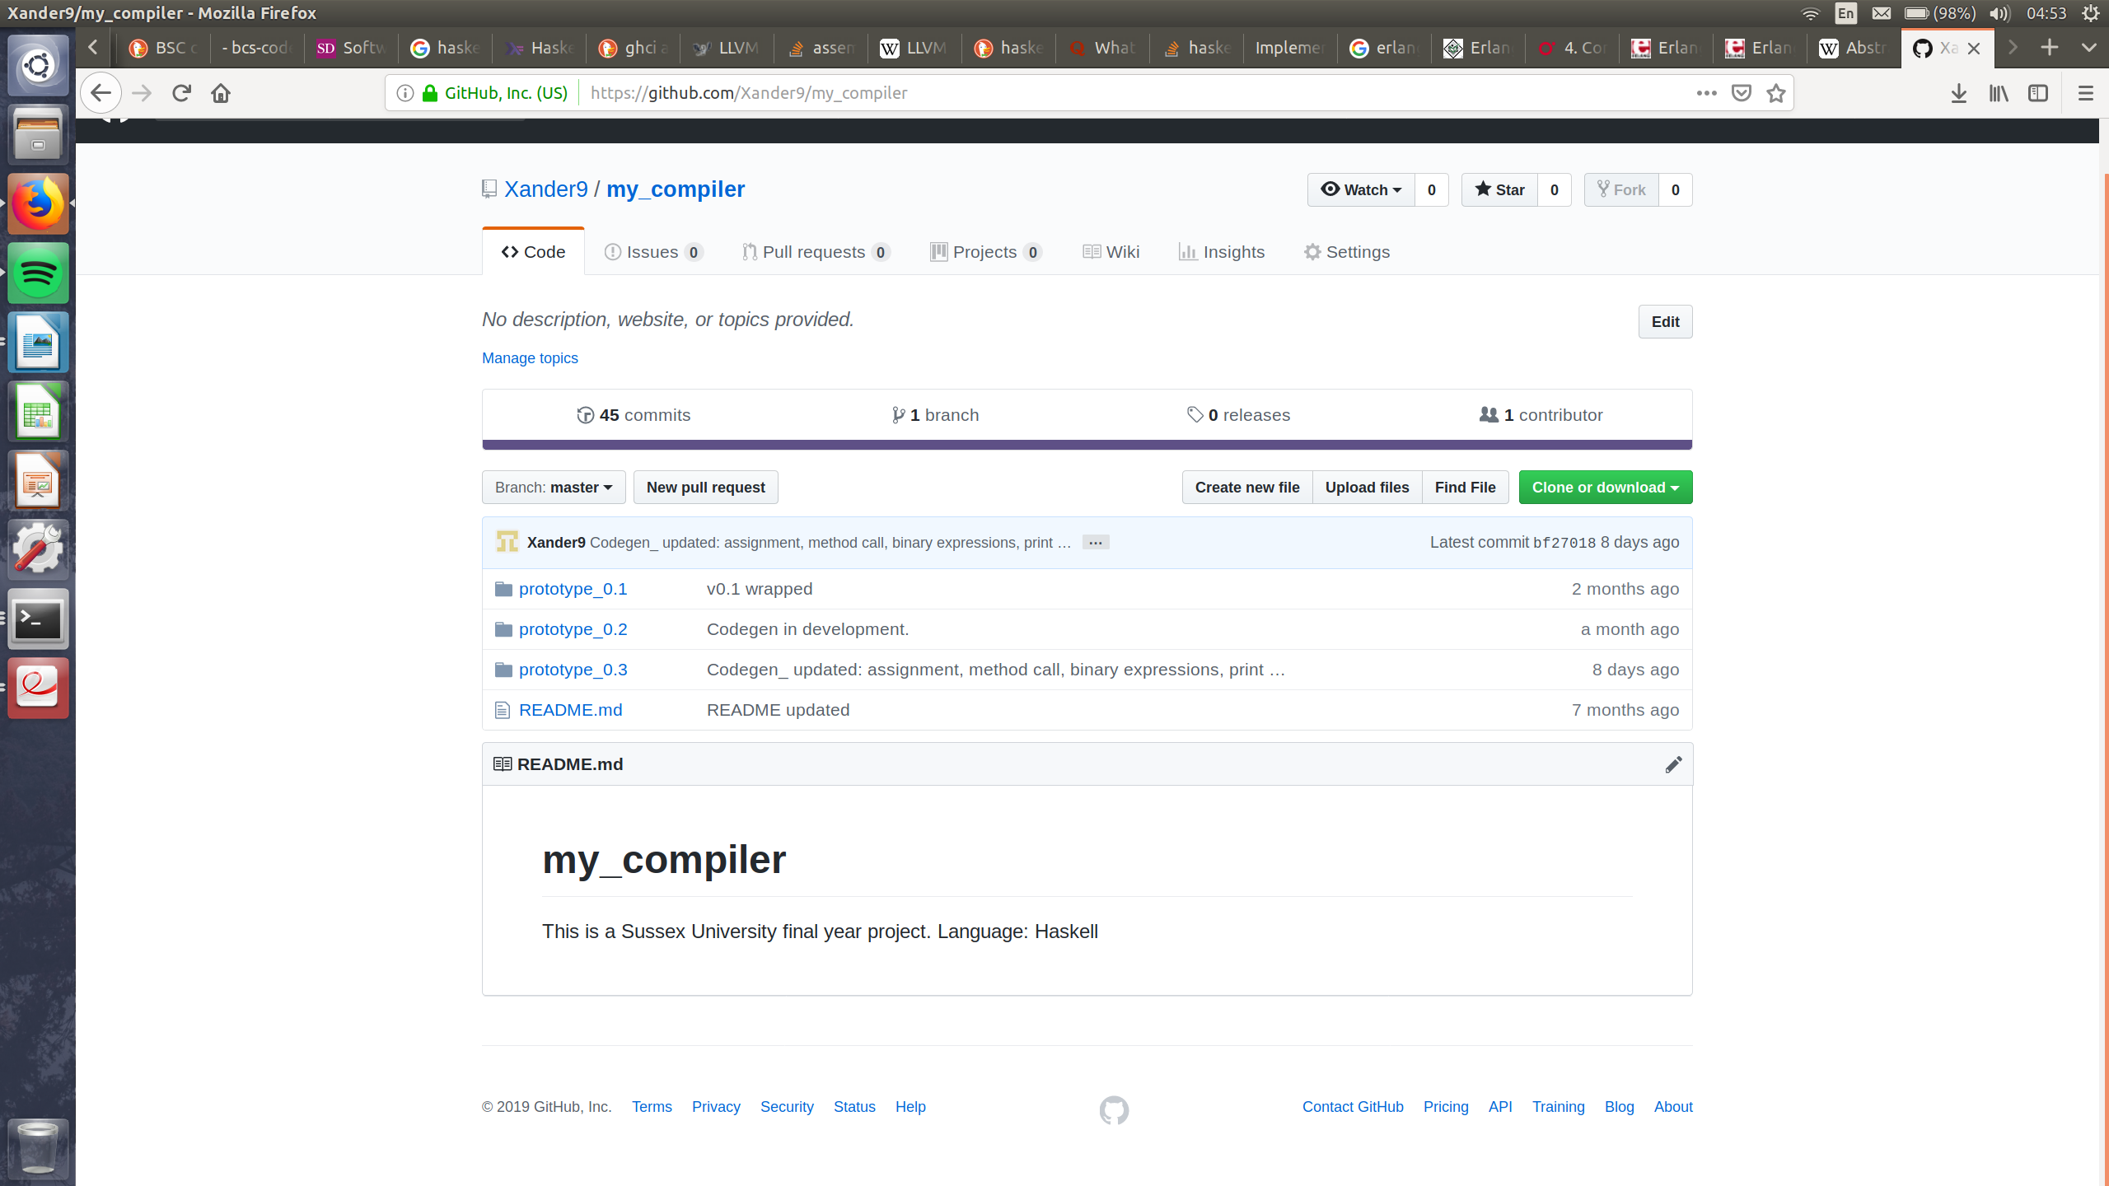

**Image 5.** Version repositories on GitHub.

The phases of the compiler were not implemented according to some specific predetermined design or blueprint. The development had fairly agile nature and specifics of implementation have been figured out on the go adjusting to arising issues and requirements of Haskell, or, eventually, LLVM framework. Thus, if a fundamental issue was faced that required altering a significant amount of code across all of the participating files one copy of the code would be saved and the work would continue on the other copy. If the altered copy was proven to be a better place to continue work, it would become a current version and the work previous copy would be wrapped. The same policy was applied for experimenting with changing significant amount of code.

##  Lexer (Lexer.hs)

Lexical analysis stage of compilation was without a doubt the easiest and fastest to implement. First, a class that will represent tokens is needed. It is simply defined as a new type class Token with relevant constructors (Semicolon, Plus, INTEGER Integer, IDENTIFIER String, etc.) corresponding to the valid elements of the source language. When a token is shown with single constructor it represents simple elements that do not need any additional data about them, like Semicolon (;), binary operators (+,-,/,*), but a constructor with a parameter, like IDENTIFIER String denotes that token contains information about itself (identifier named with a string). As was mentioned in previous chapter, lexer’s input is a string of Erleidoscope code and its processed in the following manner:

- the string is split on every occurrence of any kind of empty space character which produces a list of strings with various elements that potentially make up valid tokens;

- the split string is then gets cleaned of unnecessary empty space characters;

- following spaces comes a somewhat challenging task of fixing the appearance of strings used in the program. A special function goes over the list and traps everything in between two quotation mark characters (‘”’), e.i. when a mark is found a string is opened and consumes everything in the list until another mark is found;

- the list is then analyzed for special notations like comparison and assignment symbols using the ‘longest match’ policy ([‘:’, ‘=’] becomes [‘:=’], and [‘:’, ‘=’, ‘=’] becomes [‘:=’, ‘=’] and not [‘:’, ‘==’]);

- finally, the list contains string representations of valid tokens and is ready for tokenizatoin function;

- this function simply goes over the list and for each element puts a one of the tokens defined previously to the new list accordingly. If an element cannot be used to produce a valid token, the user is notified through an error message.

Additional points to be noted here are extra constructors in Token class and various additional supporting functions. The extra constructors (Fun [Token], Bl [Token]) are disregarded in the lexer and meant for additional processing in the parsing phase. The reason behind adding these extra constructors here an not in the parser is pretty much specific to Haskell, in that, the constructors will further represent complete functions and blocks and are required to be parts of a Token list, which would be impossible to specify in the parser because Token class is defined in the lexer.

##  Parser (Parser.hs)

Implementation of parsing was challenging and is the phase that caused the first duplicate (second revision – prototype_0.2) of the entire project to be created.

Before actual parsing takes place, some pre-processing (pre-parsing) is performed that deals with the problem of blocks bracketing and separating multiple functions in a single program. First, all curly brackets are assigned a number, as the result an opening and closing brackets with matching numbers denote opening and closing of a block. If blocks are incorrectly bracketed, parser outputs an error message. Similar actions performed with function definitions. Because it is clear that a complete function starts with ‘def’ and ends with a block, a function goes over the list of token with predefined blocks and build up functions, enclosing everything between a Def token and a block, including the block of course. Fun [Token] with enclosed Bl [Token] are now part of Token list, which is these extra constructors in the lexer’s Token type were meant for.

Parsing can now be carried out on the modified Token list. A series of recursive functions processes the list to produce an AST with accordance to the predefined AST specification at the beginning of the parser Haskell file. Almost all of the functions use pattern matching to detect valid combinations of tokens. Each valid combination results in one of the AST nodes produced or serves as a step to producing it. The AST specification in Haskell closely resembles its specification in CFG (see appendices). They are both recursive and denote what kinds of trees can be assembled from them. However, while the first and second revision of the parser (prototype_0.1 and 0.2) follow closely the tree policy, the final revision is a mixture of tree structure with some nodes defined as lists for convenience. For instance, a collection of arguments passed to a function can be a simple list of values [arg 1, arg 2, arg 3] or a continuous tree of form:

arguments

/ \

arg 1 arguments

/ \

arg 2 arguments

\

arg 3

Same logic applies for blocks being lists of expressions and lists of parameters in function definition (def main(int x, int y, int z) = {}).

In addition, regardless the recursive structure of the specification AST in Haskell, successful parsing doesn’t imply that the program is perfectly coherent. For example, function print takes an expression as its argument, both integer and a conditional are expression according to the CFG, but printing a conditional doesn’t make sense (at least in the context of Erleidoscope). The same way, binary operations (e.g. Add (E) (E)) also take expressions as arguments but logically should only accept integers, variables that had integers assigned to them and other binary operations, but this issue is dealt with in the next compilation phase.

##  Code generator (Codegen.hs)

Code generation doesn’t require additional classes to be declared. It mainly consists of some fixed strings concatenated with a function that continuously builds and returns a long string in LLVM IR based on the input AST from the parser.

Important features of this specific code generator are some pre-processing functions that detect strings used in all the functions of a Erleidoscope program and creates LLVM IR representation of them for the reasons discussed in previous chapter. Along with the string collector, there’s a function that again goes over the input AST and builds a simple storage space (memory) containing names of functions and corresponding variables and values used in them, along with variable types. This ‘memory’ is used as one of the arguments for the main code generation function (codegenProg) and is important for printing some of the data types. Initially it was also meant to help in avoid variable duplication in a function, but due to time constraints this feature was not fully implemented. Another argument passed to all code generation functions is a counter. An important advantage of LLVM is that it simulates unlimited number of registers. The counter is used to represent a register number and does not require tracking its value because of possible registers overrides. Thus, the counter is simply increased each time a new register is used in the code. It is important however to keep track of this counter within the code generator as it is being passed around all the functions in Codegen.hs and nearly every function can change its value. That is why the output of most codegen functions is a pair consisting of a LLVM IR code string, and (possibly updated) value of the counter. As was mentioned before, some predefined LLVM IR code is concatenated with the code produced by generation functions. This code is mainly used for printing purposes. Also worth mentioning, that since Erleidoscope doesn’t have type annotation for functions, their LLVM IR equivalent are typed as void and by extension, the return statement also returns void.

One of the details that require a particular use of Erleidoscope, is that LLVM does not run without a main function. Essentially, like in Java or C, a main function would have the majority of the desired operations in it or would simply make calls to other defined functions. Therefore, when writing code in Erleidoscope one should make sure that there is a main function that either contains all the expressions to be executed or have sensible calls to other functions in the program.

Another rather small but important addition to the design of the source language and consequently, the compiler, was made during Codegen.hs development and has to do with the fact that LLVM IR requires the types of function’s parameters to be declared. A simple change solution to this was adding type declaration to the grammar of Erleidoscope, but a more interesting one that would definitely expand the scope of the project would be implementing a type inferencing layer between parsing and code generation. Such feature may be proposed as a possible future improvement.

##  Compiling (Compiler.hs)

The last file simply brings together all the steps of the compiler by calling the key functions in each phase and using its output as an input for the following phases. Function ‘compile’ is meant to compile the code written manually in the terminal and applied to it.

##  Concurrency

Unfortunately, due to time constraints and some technical issues and mistakes that were made during development, the concurrency was model never had a chance to be fully or even partially implemented. At the very least the way that Erlang-like process scheduling could be implemented were theorized, but these theories require extensive experimentation to be candidates for implementation strategy.

##  Notes on testing

In later stages of the compiler development a small testing suite was developed to assess some of compiler’s functionality, but it was lost due to an accidental mistake and faulty use of Linux terminal commands.

The initial intended testing technique involved passing a series of correct and incorrect inputs to some of the main functions of each phase of the compiler. This way it could be easily determined whether the functions in question can efficiently identify correct inputs.

The lost testing suite had a number of files containing various inputs (correct in incorrect) for processing by the entire compiler. The files that would not pass lexing or parsing would obviously be considered as incorrect code. Those that would make it through code generation would be executed using LLI and correctness of the inputs would be determined by the output, e.i. whether the code runs or not, whether it produced the desired output as defined in source Erleidoscope program. However, most of these manipulations would have been performed manually which does not quite correspond with modern software engineering practices, but as a future improvement a script could be suggested that automates the aforementioned actions.

# System evaluation

As there were essentially two main parts to the project, the evaluation of the system could also be done from two perspectives. The first part is obviously compiler development and therefore the following questions could be asked about the system: Does the system handles errors adequately? Does it produce desired output given a certain input? Does it notify about incorrect inputs? All these question could be answered by performing some tests, but, because the problem with testing was explained in the previous chapter, this form of evaluation would have to be performed manually, at least with the current state and incompleteness of the system.

The second part to the project is of course concurrency, which unfortunately, never made it into the prototype by the time of submission. However, if the system was partially complete, similar evaluation methods could be carried out, questions asked, like: Do the processes actually operate concurrently and share CPU time? However, in order to properly evaluate this part of the project, it must take form of more than a theory, at least the simplest working prototype of the model.

It was said before that user testing was never considered for this project, but perhaps the simplicity and usability of the Erleidoscope could be evaluated with participants. But then again, the source language is not the focus of the project, the compiler implementation and concurrency are.

# Reflection and conclusion

It is clear that the finished product is not actually quite finished. The main reason behind its incompleteness is believed to the time constraint. To be clear, the time that was provided for development would have been sufficient if it wasn’t for some personal matters, that required attending indefinitely and took a large amount of time to be resolved. In addition, some unfortunate technical events took place, such hardware failures and accidental deletion of the entire latest iteration of the compiler with no latest additions backed up, which took some time to recover.

However, despite the evident lack of intended functionality and dropping some of the basics again due to time limitations, the current compiler is not entirely useless. Numerous manual tests has shown that basic functionality was achieved, some of witch is not even present in Kaleidoscope programming language like support for strings, booleans and printing.

Therefore, the main focus for future development beyond submission remains: adding back some functionality that was dropped; tackling implementation of concurrency model. Other future improvements and potential developments include:

- rework some of Haskell code for better readability and efficiency, especially in Codegen.hs;

- developing an extensive, automated and adjustable testing suite with Haskell and bash scripting;

– extending functionality by adding something like concatenation of strings, especially since ideas of implementing such feature exist;

- implement type inference;

- looking into Erlang-like concurrency implementation beyond scheduling, i.e. message passing;

- bring all source code together in an IDE-like graphical user interface, which, for instance would have the main area for entering Erleidoscope code, one output window for the result of compilation, LLVM IR code, another one for the results of running that code, and buttons ‘Compile’ and ‘Run’;

- a more coherent error handling system with details about the nature of an error;

- write up coherent documentation file for Erleidoscope and the compiler.

To conclude, compiler writing rightfully remains one of the most difficult but at the same time educational software engineering practices. It really gives an insight as well as a certain level of appreciation for the kind of processing real industrial strength compilers perform in the background. The scope of the attempted project is quite extensive, but definitely would have been possible to handle provided enough time. Also reflecting back, some definite adjustments to the methodology and management could have been made, fix obvious lack of testing and coherent documentation and automate certain development processes to honor modern software engineering practices. However, the current version of the compiler is unlikely to remain untouched and at least some of the aforementioned improvements shall be attempted in beyond submission and in the near future.

# References

[1] Berger, M. (2018). ‘Compilers and Computer Architecture: Introduction’ [PowerPoint presentation]. *G5035: Compilers and Computer Architecture.* Available at: http://users.sussex.ac.uk/~mfb21/compilers/slides/1.pdf [Accessed 30 April 2019]

[2] Grau, R. (2018). ‘Operating Systems Lecture 2a’ [PowerPoint presentation]. *G6059: Operating Systems*. Available at: https://matterhorn-presentation.uscs.susx.ac.uk/engage/theodul/ui/core.html?id=8f151285-3d0f-456c-b422-465635c94c64 [Accessed 28 April 2019]

[3] Haskell. (2019). ‘Features’. [Online]. Available at: https://www.haskell.org/ [Accessed 28 April 2019]

[4] Diehl, S. (2017). ‘Chapter 1 (Introduction)’. *Implementing a JIT Compiled Language with Haskell and LLVM.* [Online]. Available at: http://www.stephendiehl.com/llvm/ [Accessed 29 April 2019]

[5] The LLVM Compiler Infrastructure. (2019). ‘LLVM Overview’. *The LLVM Compiler Infrastructure.* [Online]. Available at: https://llvm.org/ [Accessed 30 April 2019]

[6] Quora. (2019). ‘What are the pros and cons of writing a compiler in Haskell?’. *Quora.* [Online]. Available at: https://www.quora.com/What-are-the-pros-and-cons-of-writing-a-compiler-in-Haskell [Accessed 1 May 2019]

[7] Erlang. (2019). ‘What is Erlang?’. [Online]. Available at: https://www.erlang.org/ [Accessed 1 May 2019]

[8] Thompson, S., Cesarini, F. (2009). ‘Chapter 4. Concurrent Programming’. *Erlang Programming.* O’Reilly. [Online]. Available at: https://www.oreilly.com/library/view/erlang-programming/9780596803940/ch04.html [Accessed 1 May 2019]

[9] Berger, M. (2018). ‘From strings to ASTs (1): lexing’ [PowerPoint presentation]. *G5035: Compilers and Computer Architecture.* Available at: http://users.sussex.ac.uk/~mfb21/compilers/slides/2.pdf [Accessed 1 May 2019]

[10] Berger, M. (2018). ‘Compilers and Computer Architecture: parsing’ [PowerPoint presentation]. *G5035: Compilers and Computer Architecture.* Available at: http://users.sussex.ac.uk/~mfb21/compilers/slides/5.pdf [Accessed 1 May 2019]

[11] Berger, M. (2018). ‘Compilers and Computer Architecture: semantic analysis’ [PowerPoint presentation]. G5035: Compilers and Computer Architecture. Available at: http://users.sussex.ac.uk/~mfb21/compilers/slides/6.pdf [Accessed 2 May 2019]

[12] Berger, M. (2018). ‘Compilers and Computer Architecture Code generation (1): stack-machines’ [PowerPoint presentation]. G5035: Compilers and Computer Architecture. Available at: http://users.sussex.ac.uk/~mfb21/compilers/slides/7.pdf [Accessed 2 May 2019]

# Appendices

##  Project log (initial)

##  Project log (final)

|  |  |  |  |  |
| --- | --- | --- | --- | --- |
|  | **Activity** | **Start Date** | **Days Spent** | **End Date** |
| **1** | Implementation language research | 25.09.2018 | 7 | 02.10.2018 |
| **2** | Learning Haskell | 02.10.2018 | 23 | 25.10.2018 |
| **3** | Project Proposal | 08.10.2018 | 3 | 11.10.2018 |
| **4** | Initial Research and Revision | 15.10.2018 | 13 | 28.10.2018 |
| **5** | Compiler Implementation, Testing and debugging | 02.11.2018 | - | ongoing |
| **6** | Interim Report | 03.11.2018 | 10 | 13.11.2018 |
| **7** | Winter break and Exam Period | 08.01.2019 | 37 | 15.02.2019 |
| **8** | Project Presentation Poster | 21.03.2019 | 1 | 22.03.2019 |
| **9** | Poster Event | 10.04.2019 | <1 | 10.04.2019 |
| **10** | Report | 28.04.2019 | 8 | 05.05.2019 |

##  Erleidoscope specification (CFG)

PROG → DEC | DEC PROG

DEC → def ID (VARDEC) = BLOCK

VARDEC → ε | VARDECNE

VARDECNE → TYPE ID | VARDECNE, TYPE ID

TYPE → Int | String | Bool

ID → ... (identifiers)

INT → ... (Integers)

BOOL → true | false

STRING → ... (Strings)

BLOCK → { ENE }

ENE → E | E; ENE

E → INT

| PRINT (E)

| STRING

| BOOL

| ID

| if E COMP E then BLOCK else BLOCK

| (E BINOP E)

| skip

| while E COMP E do BLOCK

| ID := E

| ID (ARGS)

| break

| continue

ARGS → ε | ARGSNE

ARGSNE → E | ARGSNE, E

COMP → == | < | > | <= | >=

BINOP → + | - | * | /

The read areas are the ones that were intended for implementation bu did not make it into the final revision. Identifiers are specified as [a-z]+(_|[A-Z0-9])*.

##  Erleidoscope specification (Haskell)

data PROG = Prog [DEC] deriving (Show)

data DEC = DEF (String) [PARAM] (BLOCK) deriving (Show)

data PARAM = Param (TYPE) (String) deriving (Show, Eq)

data TYPE = Int_ | String_ | Bool_ | Void_ deriving (Show, Eq)

data BLOCK = Block [E] deriving (Show, Eq)

data E =

ID (String)

| STR (String)

| INT (Integer)

| BOOL (BLN)

| BinOp (BINOP)

| COND (COMP) (BLOCK) (BLOCK)

| WHILE (COMP) (BLOCK)

| ASSIGN (String) (E)

| FUNCALL (String) [E]

| SKIP

| BREAK

| CONTINUE

| PRINT (E) deriving (Show, Eq)

data BLN = T | F deriving (Show, Eq)

data COMP = Eq (E) (E) | Less (E) (E) | Greater (E) (E) | LessEq (E) (E) | GreaterEq (E) (E) deriving (Show, Eq)

data BINOP = Add (E) (E) | Sub (E) (E) | Mult (E) (E) | Div (E) (E) deriving (Show, Eq)

Additional important notes about Erleidoscope include:

- comparison in a conditional (if statement) can only be performed on simplest expressions like integers and identifiers that point to integers;

- while loop supported in front end (parser and lexer), but not back end (code generation), same for SKIP, BREAK and CONTINUE;

- binary operations do not support brackets;

- strings must be assigned to a variable before printing using them as arguments for function calls;

- when calling a function all arguments must be assigned to variables;

- all expressions in blocks must be separated by a semicolon, including complete if-then-else statements.

##  Code and output examples

Input (Erleidoscope):

def foo(int x, string y, string z) = {

if x == 0 then {

print(y);

} else {

print(z);

};

}

def main() = {

x := "It's been an honour";

y := "to be under your supervision";

xi := 0;

foo(xi, x, y);

yi := xi + 1;

foo(yi, x, y);

z := "Sir";

print(z);

}

Output (LLVM IR):

@.main.x = private constant [21 x i8] c"It's been an honour\0A\00"

@.main.y = private constant [30 x i8] c"to be under your supervision\0A\00"

@.main.z = private constant [5 x i8] c"Sir\0A\00"

@.IntegerPrint = private constant [4 x i8] c"%d\0A\00"

@True = private constant [6 x i8] c"true\0A\00"

@False = private constant [7 x i8] c"false\0A\00"

declare i32 @printf(i8*, ...)

define void @bool_print(i1 %x)

{

entry:

%bl = icmp eq i1 %x, 1

br i1 %bl, label %truePrint, label %falsePrint

falsePrint:

%False = getelementptr [7 x i8], [7 x i8]* @False, i32 0, i32 0

call i32 (i8*, ...) @printf(i8* %False)

br label %cont

truePrint:

%True = getelementptr [6 x i8], [6 x i8]* @True, i32 0, i32 0

call i32 (i8*, ...) @printf(i8* %True)

br label %cont

cont:

ret void

}

define void @foo(i32 %x, i8* %y, i8* %z)

{

%if.1 = icmp eq i32 %x, 0

br i1 %if.1, label %then.1, label %el.1

then.1:

call i32 (i8*, ...) @printf(i8* %y)

br label %cont.1

el.1:

call i32 (i8*, ...) @printf(i8* %z)

br label %cont.1

cont.1:

ret void

}

define i32 @main()

{

%x = getelementptr [21 x i8],[21 x i8]* @.main.x, i32 0, i32 0

%y = getelementptr [30 x i8],[30 x i8]* @.main.y, i32 0, i32 0

%1 = alloca i32, align 4

store i32 0, i32* %1, align 4

%xi = load i32, i32* %1, align 4

call void @foo(i32 %xi, i8* %x, i8* %y)

%2 = alloca i32, align 4

%3 = add i32 %xi, 1